|  |  |
| --- | --- |
| **The Guzzler** | waratah logo |

**Description**

The machine proposed in unique in its application and design and has been specifically designed to suit the operating conditions at Pike River Mine.

The Guzzler operates in conjunction with a purpose designed Fletcher ‘Mobile Roof Support’ which incorporates a Monitor employed for cutting the coal with a high pressure and high volume water jet.

**Functions**

The Guzzler is designed to provide a barrier in the roadway to control and direct the coal & water mix into the roadway flume system and break any material to less than 200mm.

It is crawler track mounted, self propelled with radio controlled functions

**Operating parameters**

Roadway width 4,400mm

Roadway height 3,500mm

Roadway gradient 1 in 15 nominal

Floor strata

**Machine parameters**

Weight 30 Tonnes

Length 8,000mm

Transport width 2,600mm

Maximum operating width 5,000mm

**Machine Specification**

**Breaker**

Motor 75kW 1000VAC

Gearbox Spiral bevel single reduction (3:1 ratio)

Coupling Flexible

Breaker Impact with tungsten carbide hammers

Hammer speed 500 rpm

Tip diameter 800mm

Tip peripheral speed

Height range (over deckplate) 150/200/250mm

**Doors**

Length 1,500mm

Height 1,500mm

Thickness 75mm

Guillotine 1,450mm long x 200mm stroke x 25mm thick- 2off per side

**Chassis**

Length 8,000mm

Height 1,500mm

Width 2,600mm

Plate 20mm

**Hydraulic System**

Pump motor 75kW 1000VAC

Pump 100 litres per minute

Operating pressure 100bar

Oil reservoir 300 litres

Oil type ISO VG68

Hoses and fittings MDG41 compliant

Filtration 10 micron absolute

Floor jacks x 4

Guillotine cylinders x 4

**Traction**

Track width 600mm

**Electrical System**

Main enclosure FK2005 with integral isolation

Radio remote control Obelix

Emergency Stop x 2 TK2003

**Operating cycle**

1. Guzzler located in centre of roadway with doors set to roadway rib on both sides and guillotine deployed to seal doors to the floor, discharge located directly over the flume.
2. The operator is positioned behind the door for protection
3. The operator starts the Breaker from the remote control.
4. The operator starts the Monitor from the remote control
5. The operator controls the direction of the Monitor jet and cuts the coal, washing it into the mouth of the Guzzler.
6. The coal slurry is directed through the Guzzler, large lumps of coal or rock are broken by the Breaker to less than 200mm and delivered into the flume.
7. When coal cutting is complete, the Monitor is stopped by the operator using the remote control.
8. The Breaker is stopped by the operator using the remote control.
9. The guillotines are fully raised using the manual control valves
10. The doors of the Guzzler are closed across the inbye end using the manual control valves and the doors secured closed.
11. The Guzzler is lifted off the floor with the manually operated controls operating the 4 floor jacks.
12. 10m of flume is removed.
13. The operator drives the Guzzler outbye using the remote control and repositions it with its discharge over the flume and lowers the Guzzler to the floor.
14. The MRS with integral Monitor is trammed outbye by the operator using the remote control an repositioned and set to the roof in the roadway ready for coal cutting.
15. The doors and guillotine are redeployed using the manual controls.
16. The cutting and loading cycle recommences.

**Control system for Pike River – MRS, Monitor & ‘Guzzler’**

**Transmitter Concept Layout**

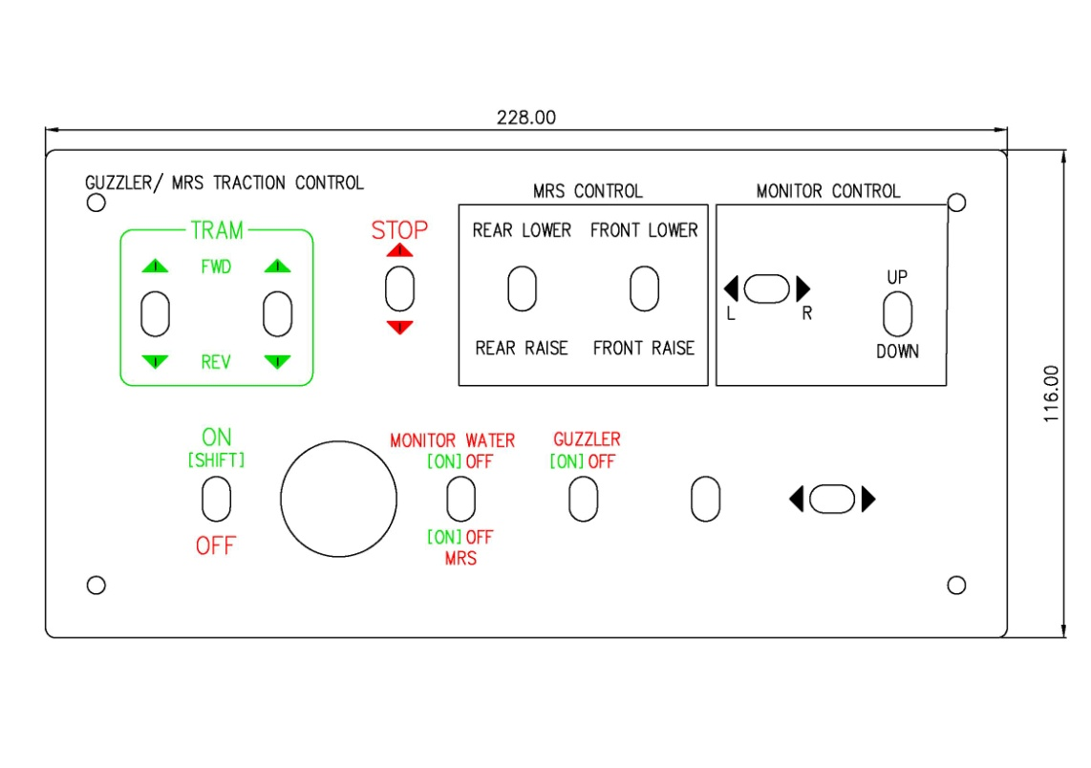

**Radio remote control**

MRS – Traction Left track forward/ reverse

MRS – Traction Right track forward/ reverse

MRS – Set/lower front

MRS – Set/lower rear

MRS – On/Off

Monitor - Left/right slew

Monitor - Up/down

Monitor – Water on/off

FB - Traction left track forward/ reverse

FB - Traction right track forward/ reverse

Emergency stop – Stops the monitor pump, Guzzler pump motor, Guzzler breaker motor, MRS....

**Manual operation**

FB – Raise/lower front

FB – Raise/lower rear

FB Left door Forward/Reverse

FB Right door Forward/Reverse

FB Left guillotine Up/down

FB Right guillotine Up/down